|  |
| --- |
| **Power on** |
| Rotate telescope UP |
| Remove cover and stow |
| Check all breakers in |
| Archiver computer power on |
| Laser red switch ON |
| Laser key ON |
| Wait for Q-SW power |
| Click Shutter ON |
| Click LDD ON |
| Click Menu |
| Click Enter twice, to unlock power setting |
| Rotate wheel to set power to 28.5 A |
| Click Enter once to lock power setting |
| **hsrl computer** |
| Log in as user: hsrl passwd: %Lidar1543 |
| start_all |
| hsrl_status |
| Should show all processes running |
| If problems, rerun start_all. |
| **HSRL control via the GUI** |
| Bring up GUI in browser (hsrl:8083) |
| Click on *Detector Shutter In* twice to open shutter– no check mark |
| Click Main Shutter twice – OPEN - green |

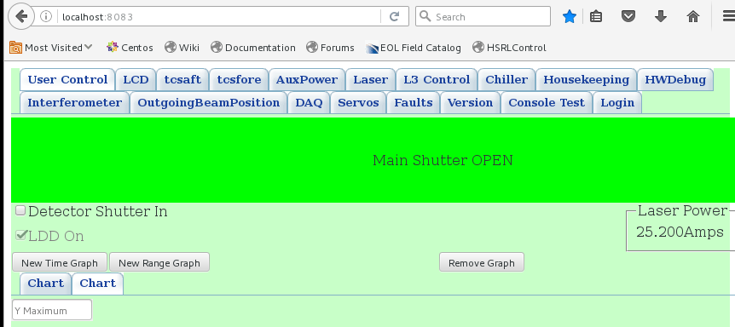

|  |
| --- |
| Click on *New Range Graph* |
| On graph, select Y1 forRaw-CombHiRaw-MolRaw-Xpol |
| Click on *Force Update* |
| You should see a graph |

|  |
| --- |
| **hsrl-archiver computer** |
| Log in to archiver: ssh –XY hsrl-archiver |
| user: hsrl passwd: %Lidar1543 |
| Open a Terminal |
| start_all |
| pcheck |
| pcheck should report 0 processes down |
| start_HawkEye.ops |
| HawkEye window should pop up, and show reasonable data |
| pdm |
| PrintDataMap should show data updating |

|  |
| --- |
| **Before Take-off** |
| On GUI, close main shutter (red) |
| Point telescope down |

|  |
| --- |
| **After Take-off** |
| On GUI, open main shutter (green) |
| Point telescope as required |

|  |
| --- |
| **Before landing** |
| On GUI, close main shutter (red) |
| Point telescope down |

|  |
| --- |
| **Shutdown** |
| On hsrl-archiver computer: |
| Transfer data to USB stick if needed |
| sudo poweroff |
| On hsrl computer: |
| stop_all |
| sudo poweroff |
| On laser unit: |
| Click *Enter* to unlock power setting |
| Using wheel, reduce power to 0.0 A |
| Click *Enter* to lock power setting at 0 A |
| Laser key OFF |
| Laser red switch OFF |
| Pull breakers for:Thermal ctrl powerComputer powerLaser power |
| Point telescope up, install cover |
| Point telescope down |

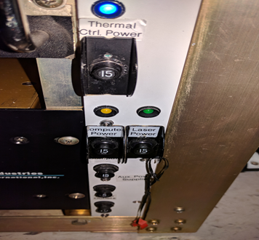

HSRL Breakers  
All breakers in to startup  
Arrow breakers off on shutdown

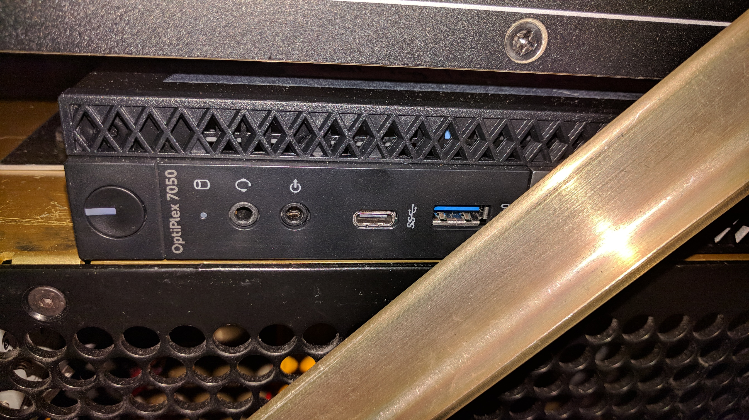

Archiver power

Power ON (LED white)

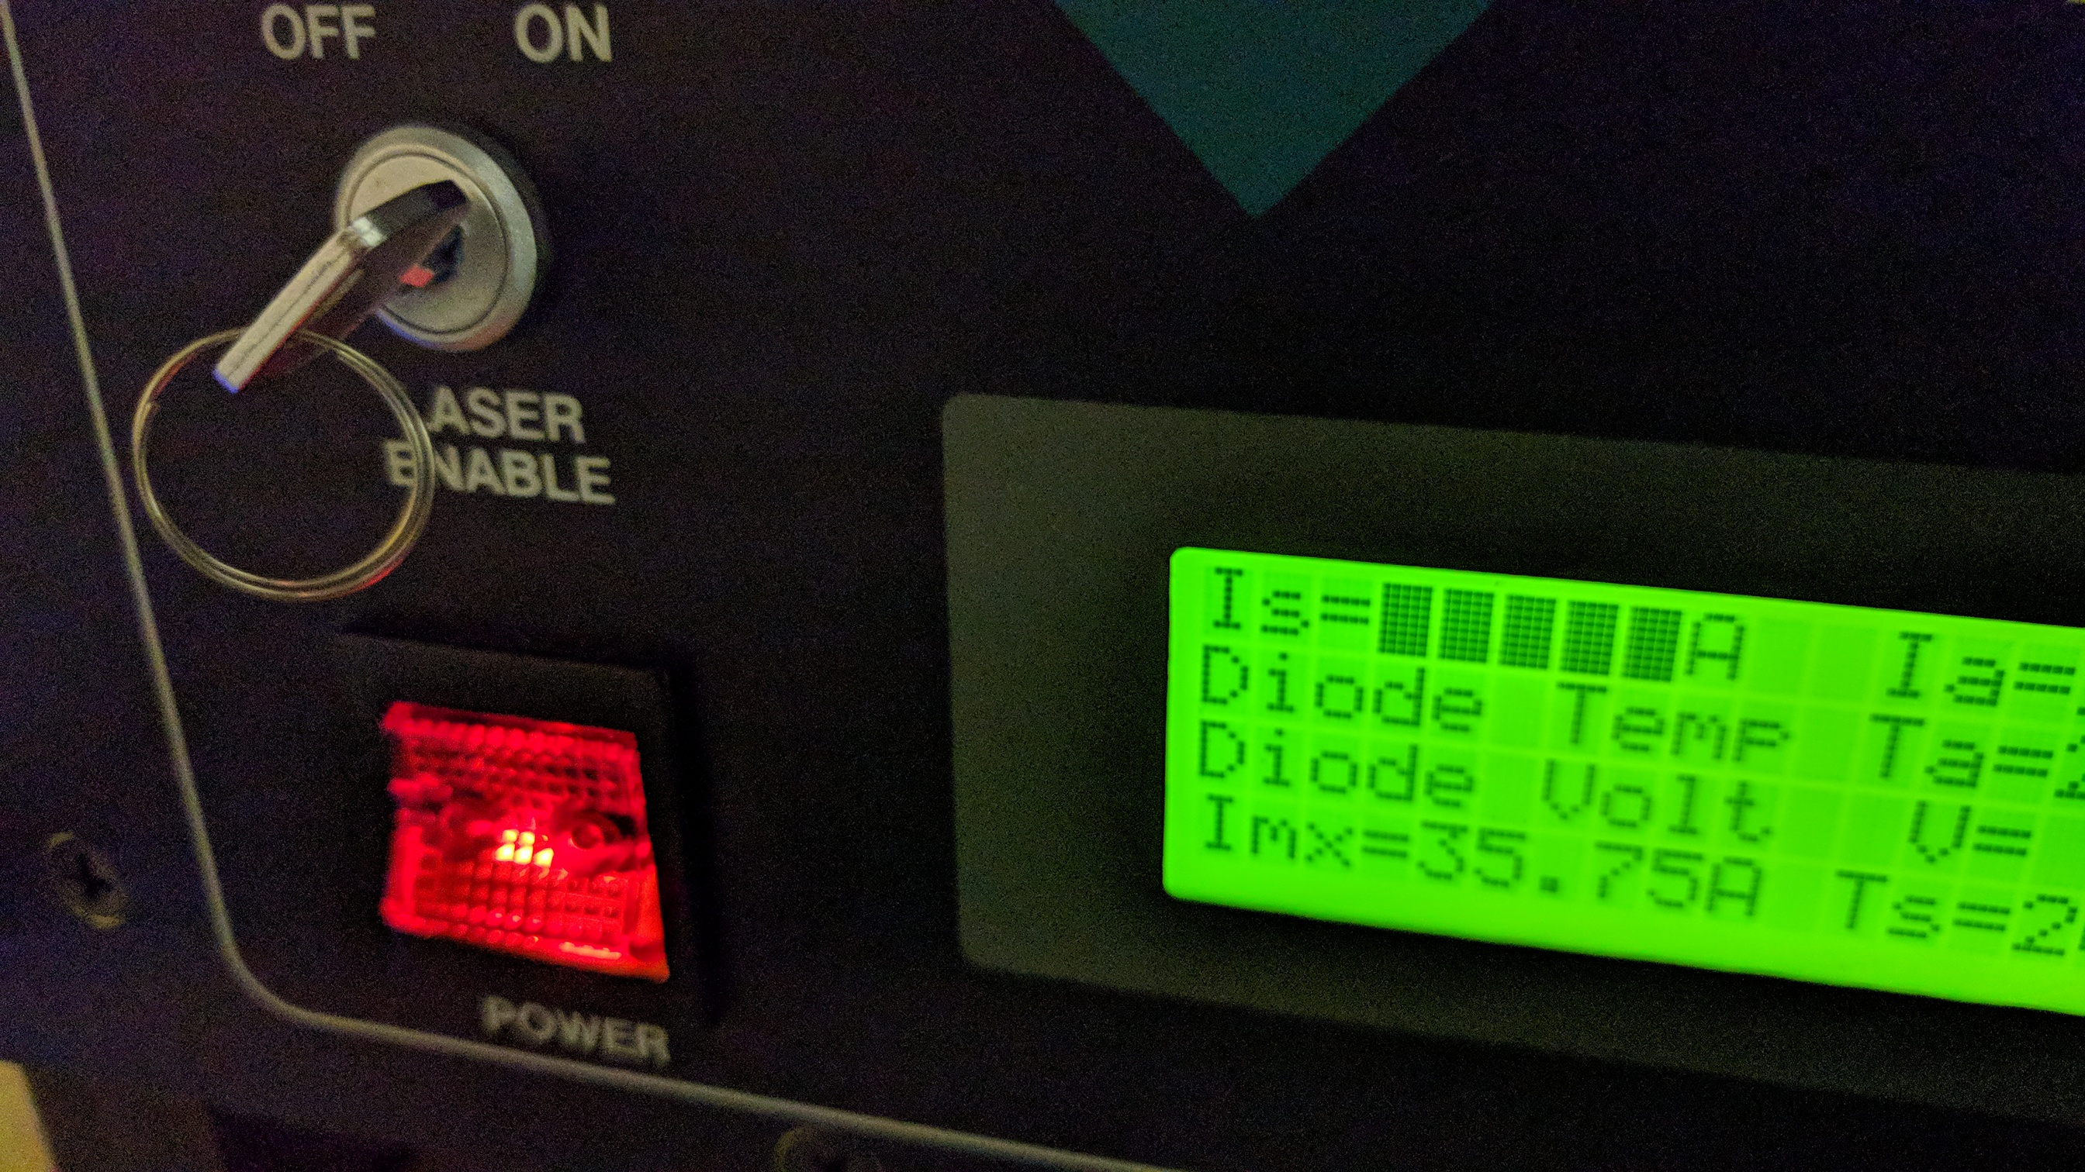

2

1

Laser power:

* Red switch ON
* Key ON

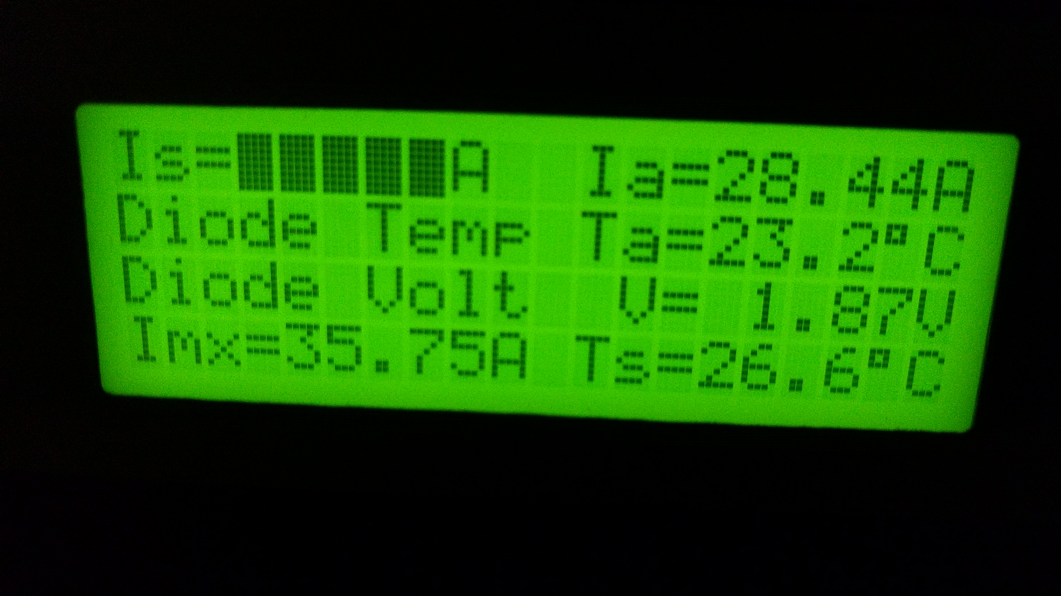

Power setting locked – flashing shaded

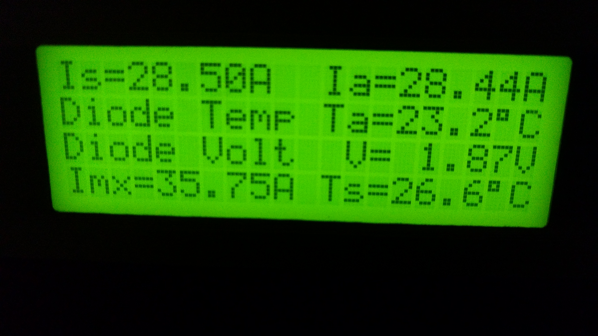

Power setting unlocked – no shading

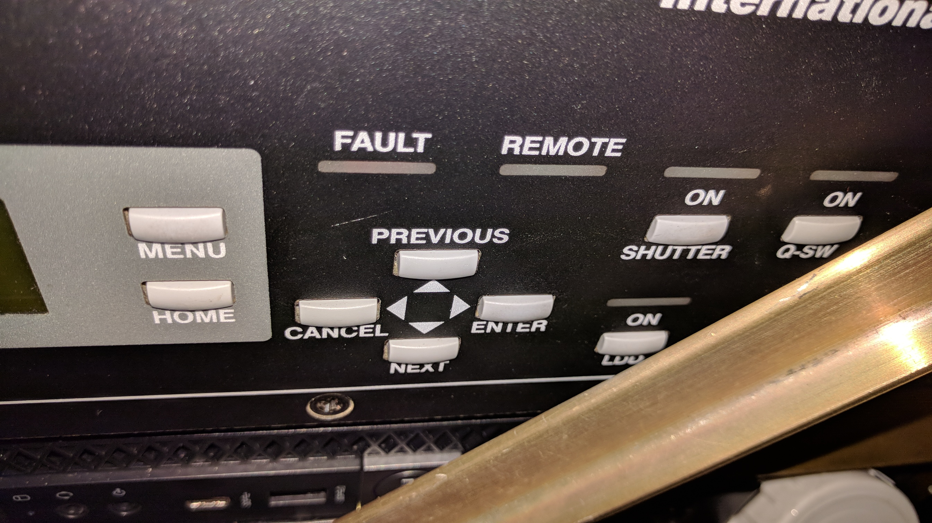

5/7

3

4

2

1

1. Wait for Q-SW ON  
2. Click shutter ON  
3. Click LDD ON  
4. Hit Menu  
5. Hit Enter twice to unlock power setting.

Check shading is off

6. Set current to 28.5 A on wheel

7. Hit Enter again to lock

Setting the laser current:

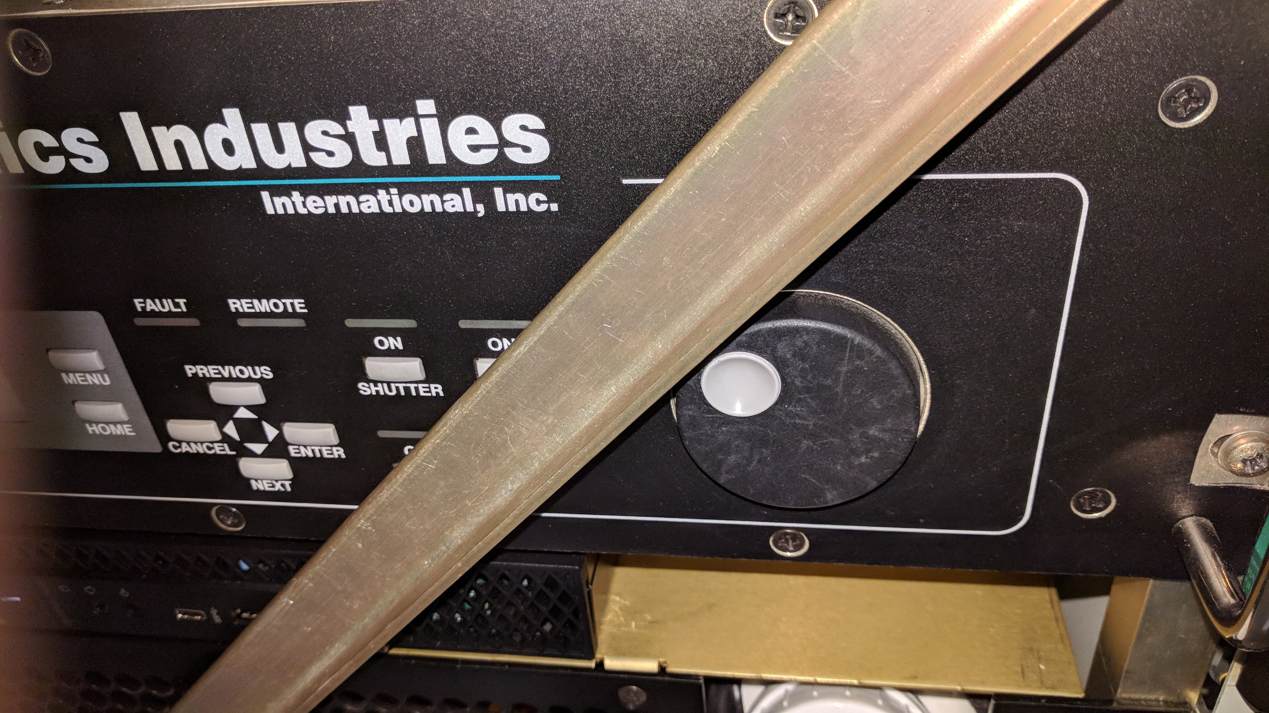

Rotate wheel to set Is current to:  
 28.5 A (ON)  
 0.00 A (OFF)